**CS308 Folio Tracker Initial GUI and Back-end API Design**

**Overview**

This application is used to manage stock portfolios and view the value of both individual stocks and the total value of your portfolio.

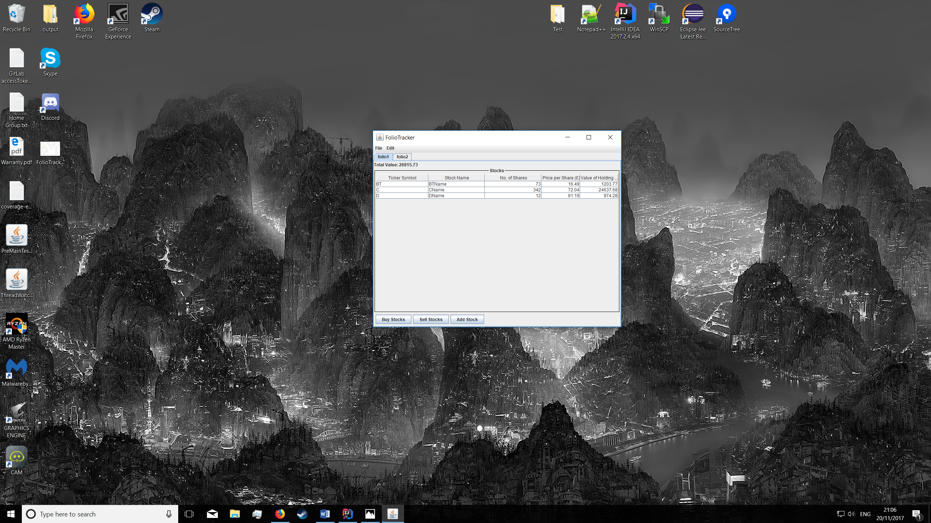

As shown above, the GUI features and easy to use menu bar at the top of the screen with two menus. Under the first menu, users are able to save the current folio they are working on to a file or load a new folio from a pre-existing file. Using the ‘edit’ menu, users are able to create and delete portfolios. However, to insure against accidental deletion a confirmation pop-up will be displayed to double check whether the deletion is intentional. The above image also highlights the ability to manage more than one folio. There are also several buttons at the bottom of the screen which allow the user to buy, sell and add stocks.

The above image also shows the information which is available to the user while using the programme such as: number of shares, price per share and value of holdings. As an added feature the price and value will refresh automatically to give the most up to date information and the total value of your folio is displayed in a clear way in the top left hand corner.

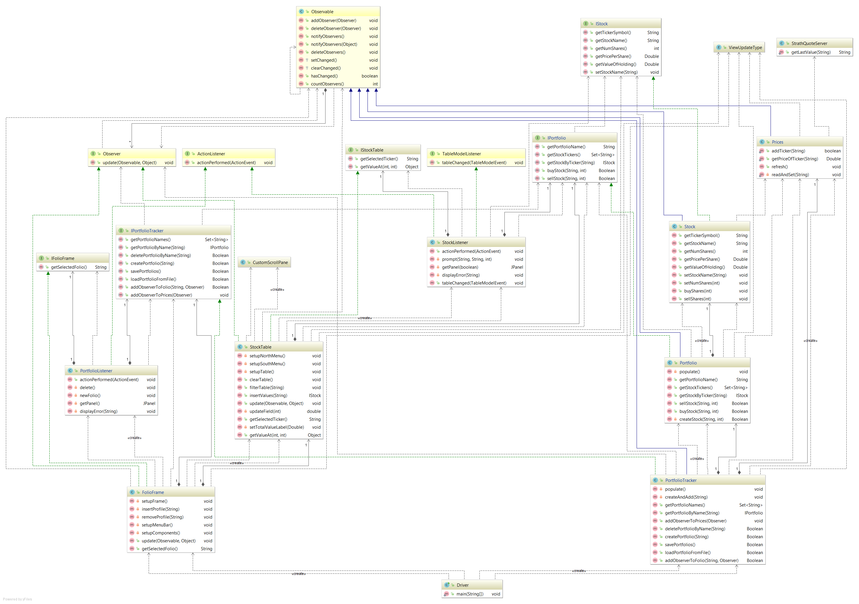

**API Overview**

IStock is mainly used as a way to get data out of the stock object the only modification that happens directly is of the name. We felt that everything else like buying and selling of stock could be handled a level up in IPortfolio.

IPortfolio is used to maintain the stocks in a portfolio. Such as the buying and selling of stocks by ticker name, this is handled in IPortfolio as this allows it to be handled centrally and it can handle cases where a stock will have to be created or deleted.

IPortfolioTracker is used to handle and maintain individual portfolios. It allows basic operations such as creating/deleting and saving/loading.

**Specification API**

IPortfolio:

effects: returns the name associated with this portfolio

String getPortfolioName();

effects: returns all the tickers owned within this portfolio

Set<String> getStockTickers();

requires: ticker != null

effects: returns the IStock with the ticker value of the parameter ticker, if ticker is not associated to any stock then returns null

IStock getStockByTicker(String ticker);

requires: ticker != null, numOfShares >0

modifies: this

effects: if tickerSymbol is known to the portfolio then increases number of shares by numOfShares in the associated stock and returns true, else if the ticker is a real stock ticker then a stock is created with the tickerSymbol and numOfShares and returns true, otherwise false.

Boolean buyStock(String ticker, int numOfShares);

requires: ticker != null, numOfShares >0

modifies: this

effects: if ticker is not known to the portfolio returns null otherwise if associated stock has enough shares then decreases number of shares by numOfShares and returns true else false;

Boolean sellStock(String ticker, int numOfShares);

IStock:

effects: returns the ticker associated with this Stock

String getTickerSymbol();

effects: returns the name associated with this stock

String getStockName();

effects: returns the number of shares owned

int getNumShares();

effects: returns the value of a share of this stock

Double getPricePerShare();

effects: returns the total value of this stock

Double getValueOfHolding();

requires: stockName != null

effects: sets the name associated with this stock to stockName

void setStockName(String stockName);

IPortfolioTracker:

effects: returns all the portfolio names in the tracker

Set<String> getPortfolioNames();

requires: name != null

effects: returns the folio associated with name, if none found then return null

IPortfolio getPortfolioByName(String name);

effects: returns false if folio with name doesn’t exist otherwise removes folio with name returns true

Boolean deletePortfolioByName(String name);

effects: returns false if folio with name already exists otherwise creates new folio with name and returns true

Boolean createPortfolio(String name);

effects: returns true if folios saved to disk otherwise false

Boolean savePortfolios();

effects: returns true if folios loaded from disk otherwise false

Boolean loadPortfolioFromFile();

requires: folioName != null, observer != null

effects: folioName isn’t associated to a folio then return false, otherwise adds observer as an observer to the folio associated with folioName returns true;

Boolean addObserverToFolio(String folioName, Observer observer)

requires: observer != null

effects: adds observer as an observer to prices

void addObserverToPrices(Observer observer);

**GUI Features**

**Creating a Portfolio**

You can create a new portfolio by using the drop down ‘edit’ menu and selcting ‘new folio’. A pop is then displayed prompting for a name. The new folio will then be displayed in the view shown in *figure 3.*

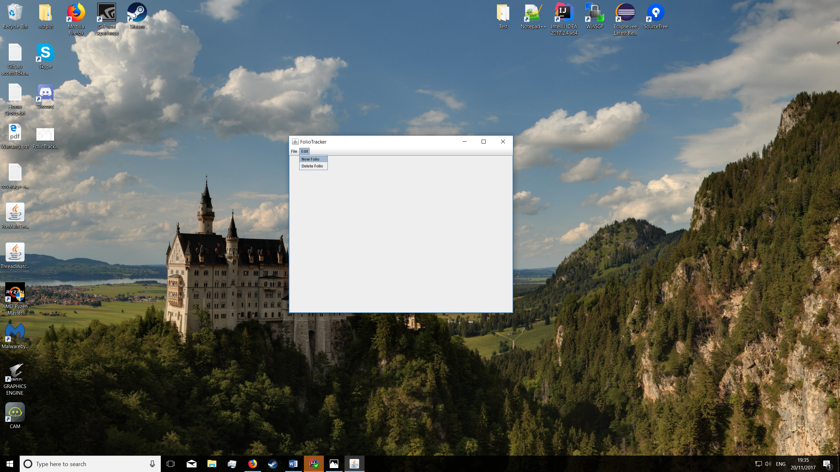

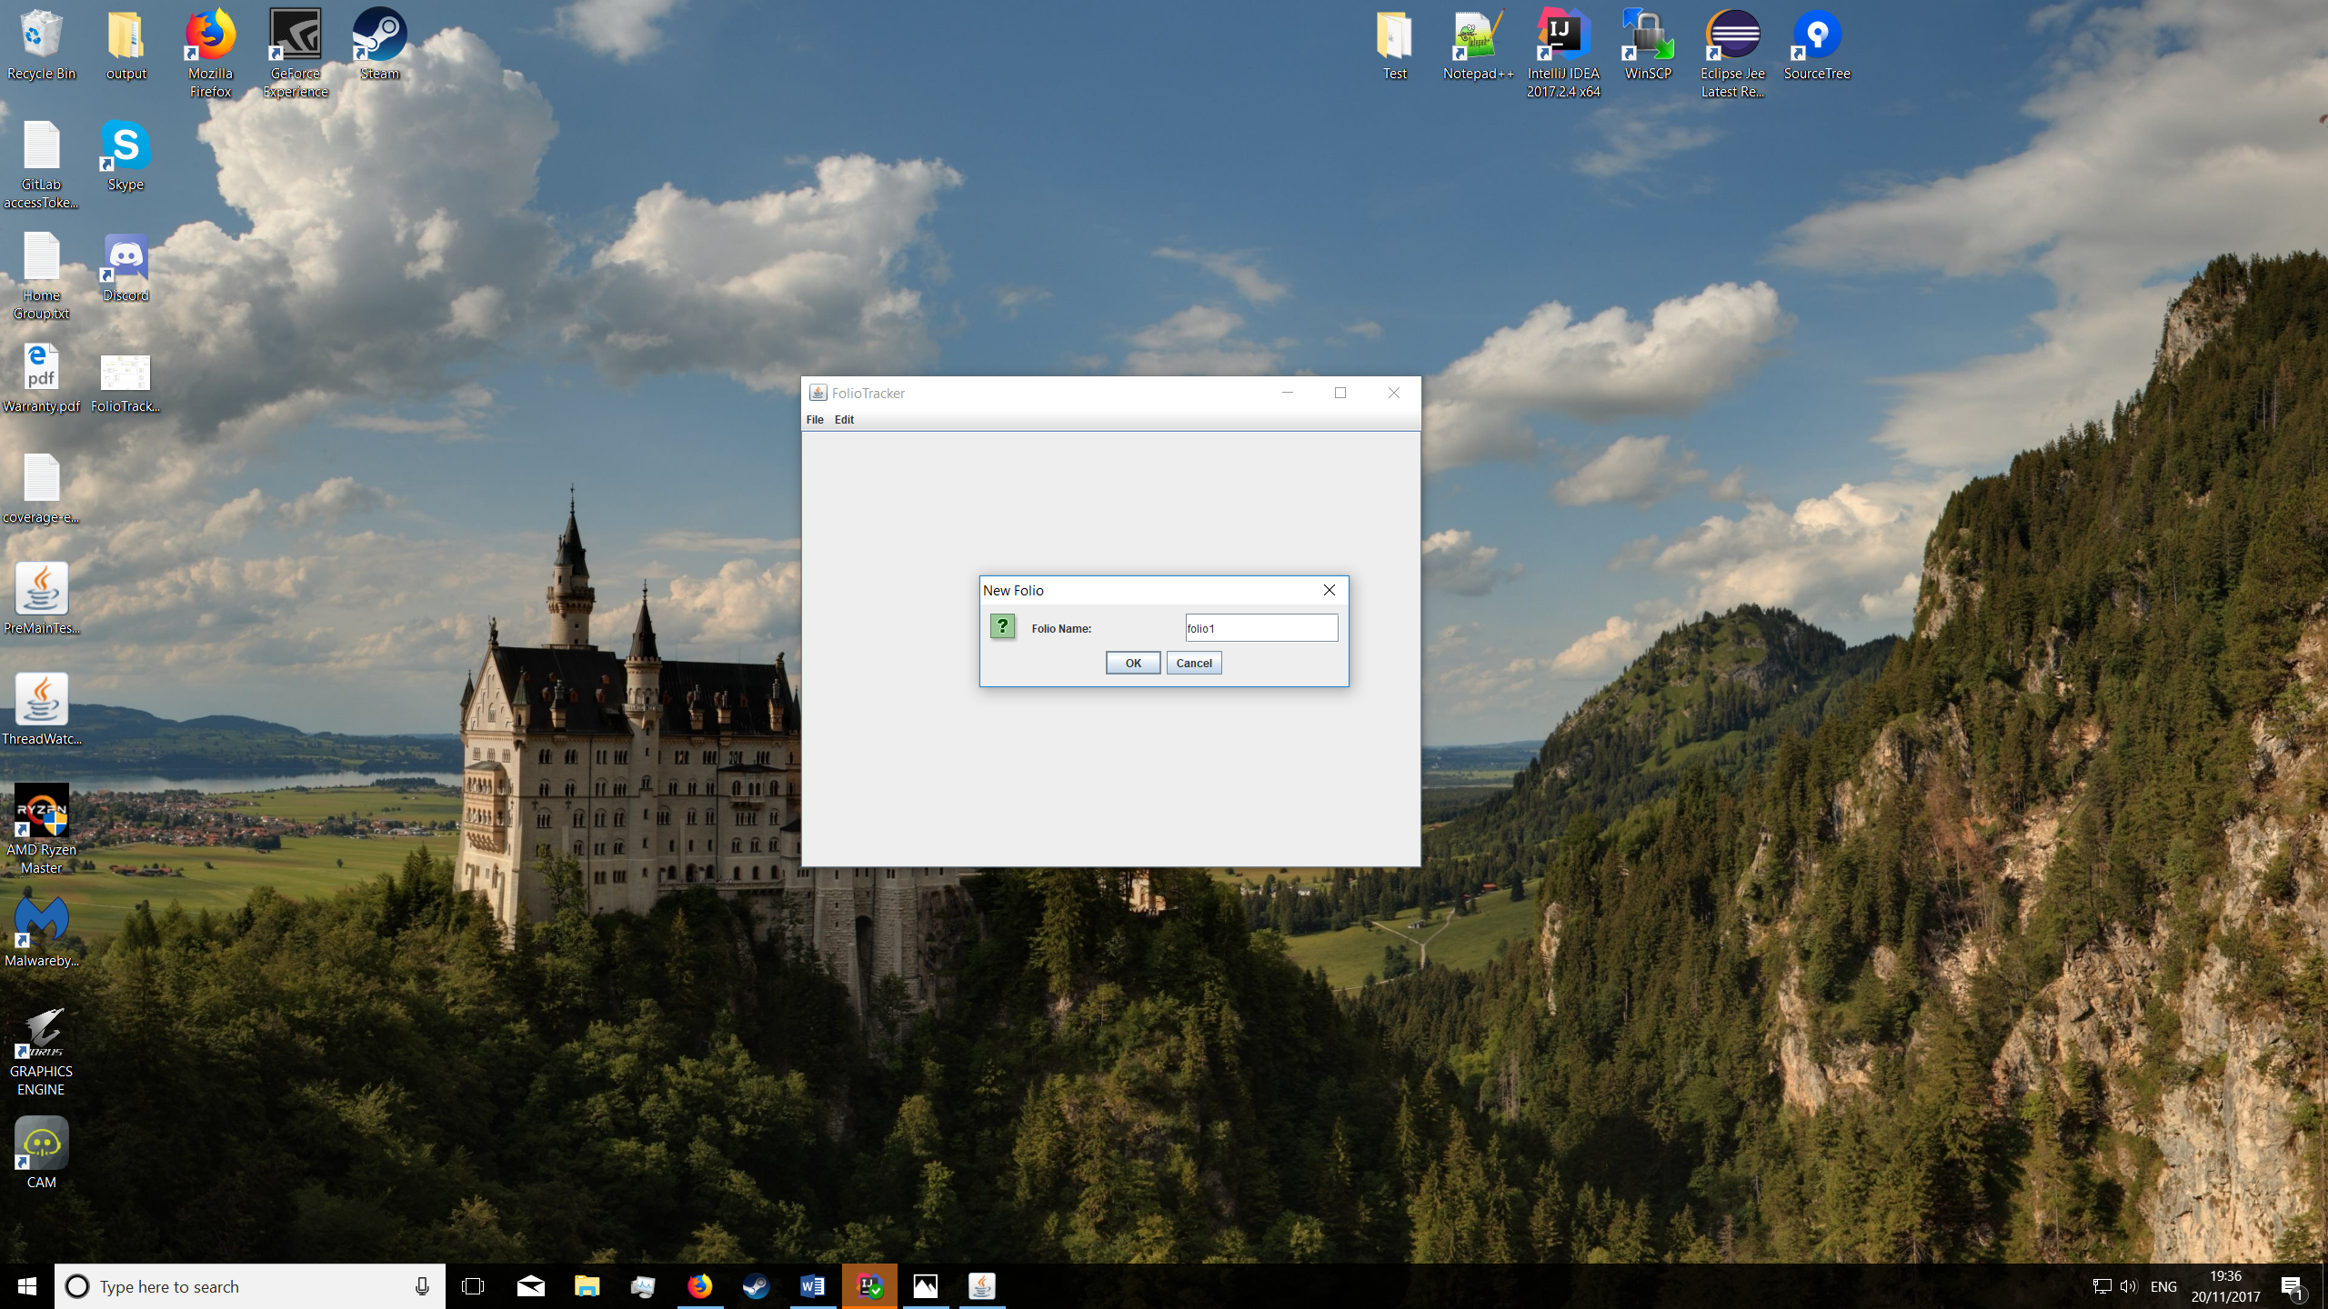Figure 1 – Menu bar options (new)

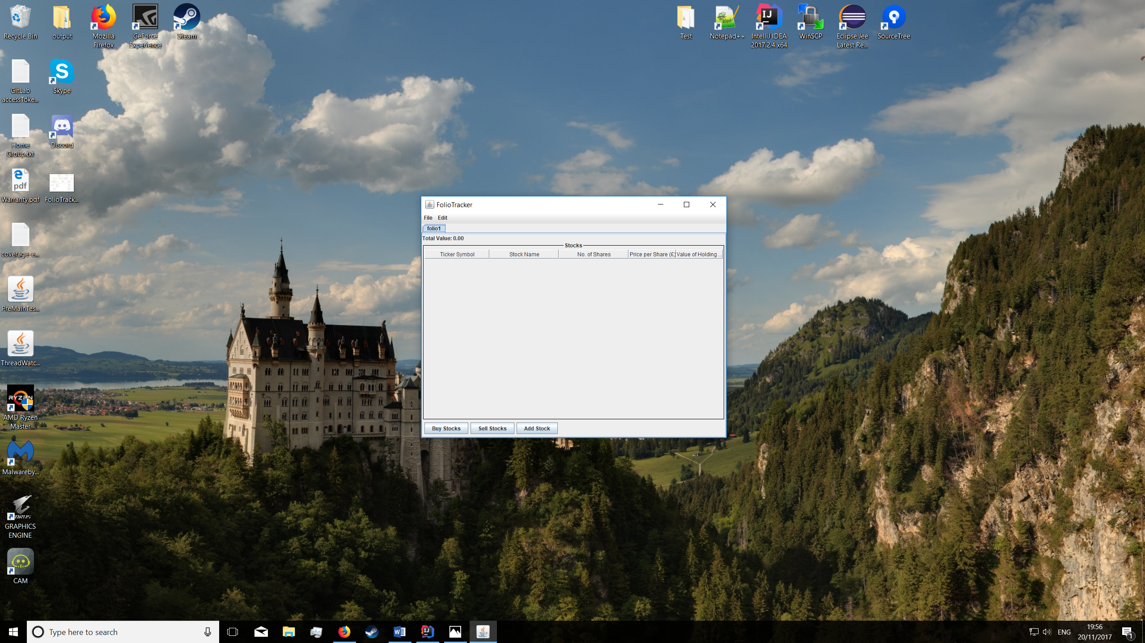Figure 2 – Name prompt

Figure 3 – New portfolio

**Deleting a Portfolio**

You can delete a new portfolio by using the drop down ‘edit’ menu and selcting ‘delete folio’. A pop up will then appear to confirm the deletion. Once confirmed, the folio will be deleted and no longer visible; as shown in *figure 6.*

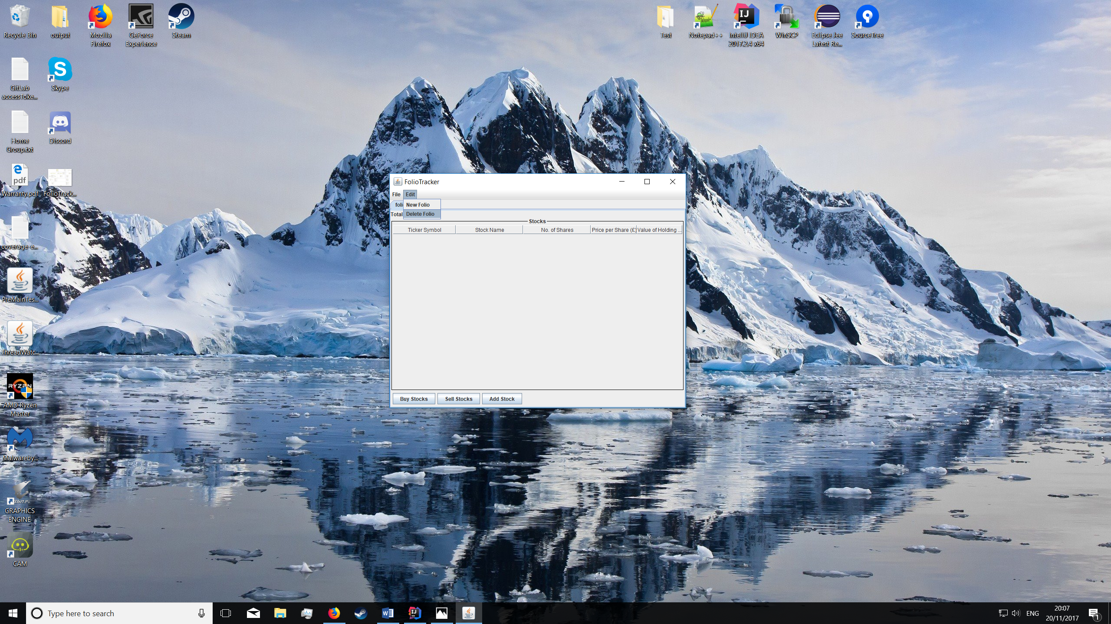

Figure 4 – Menu bar options (delete)

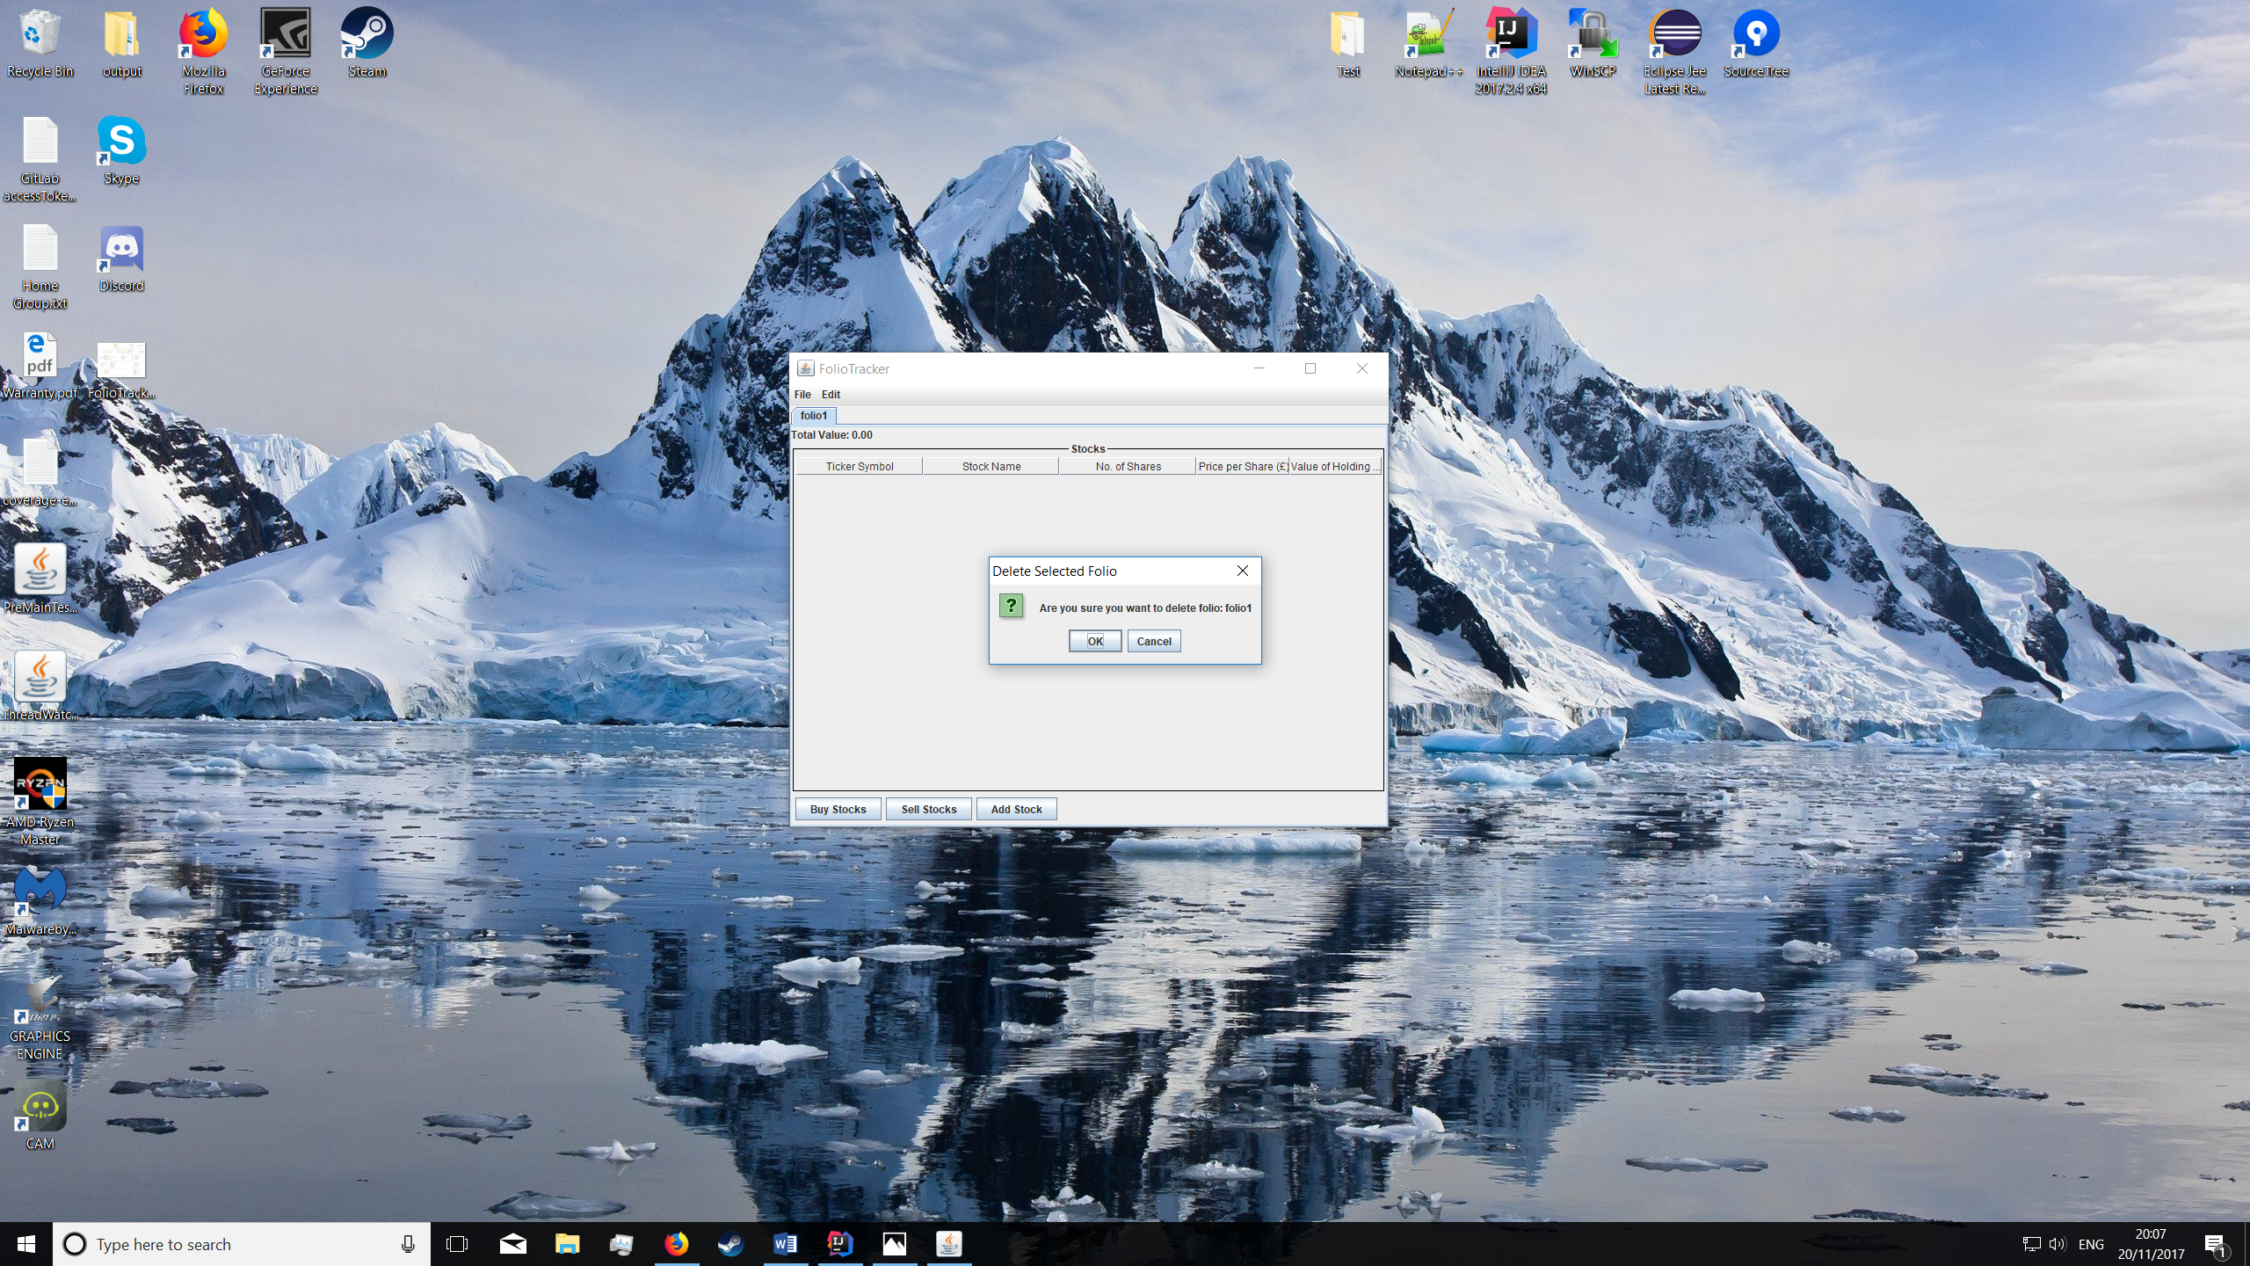

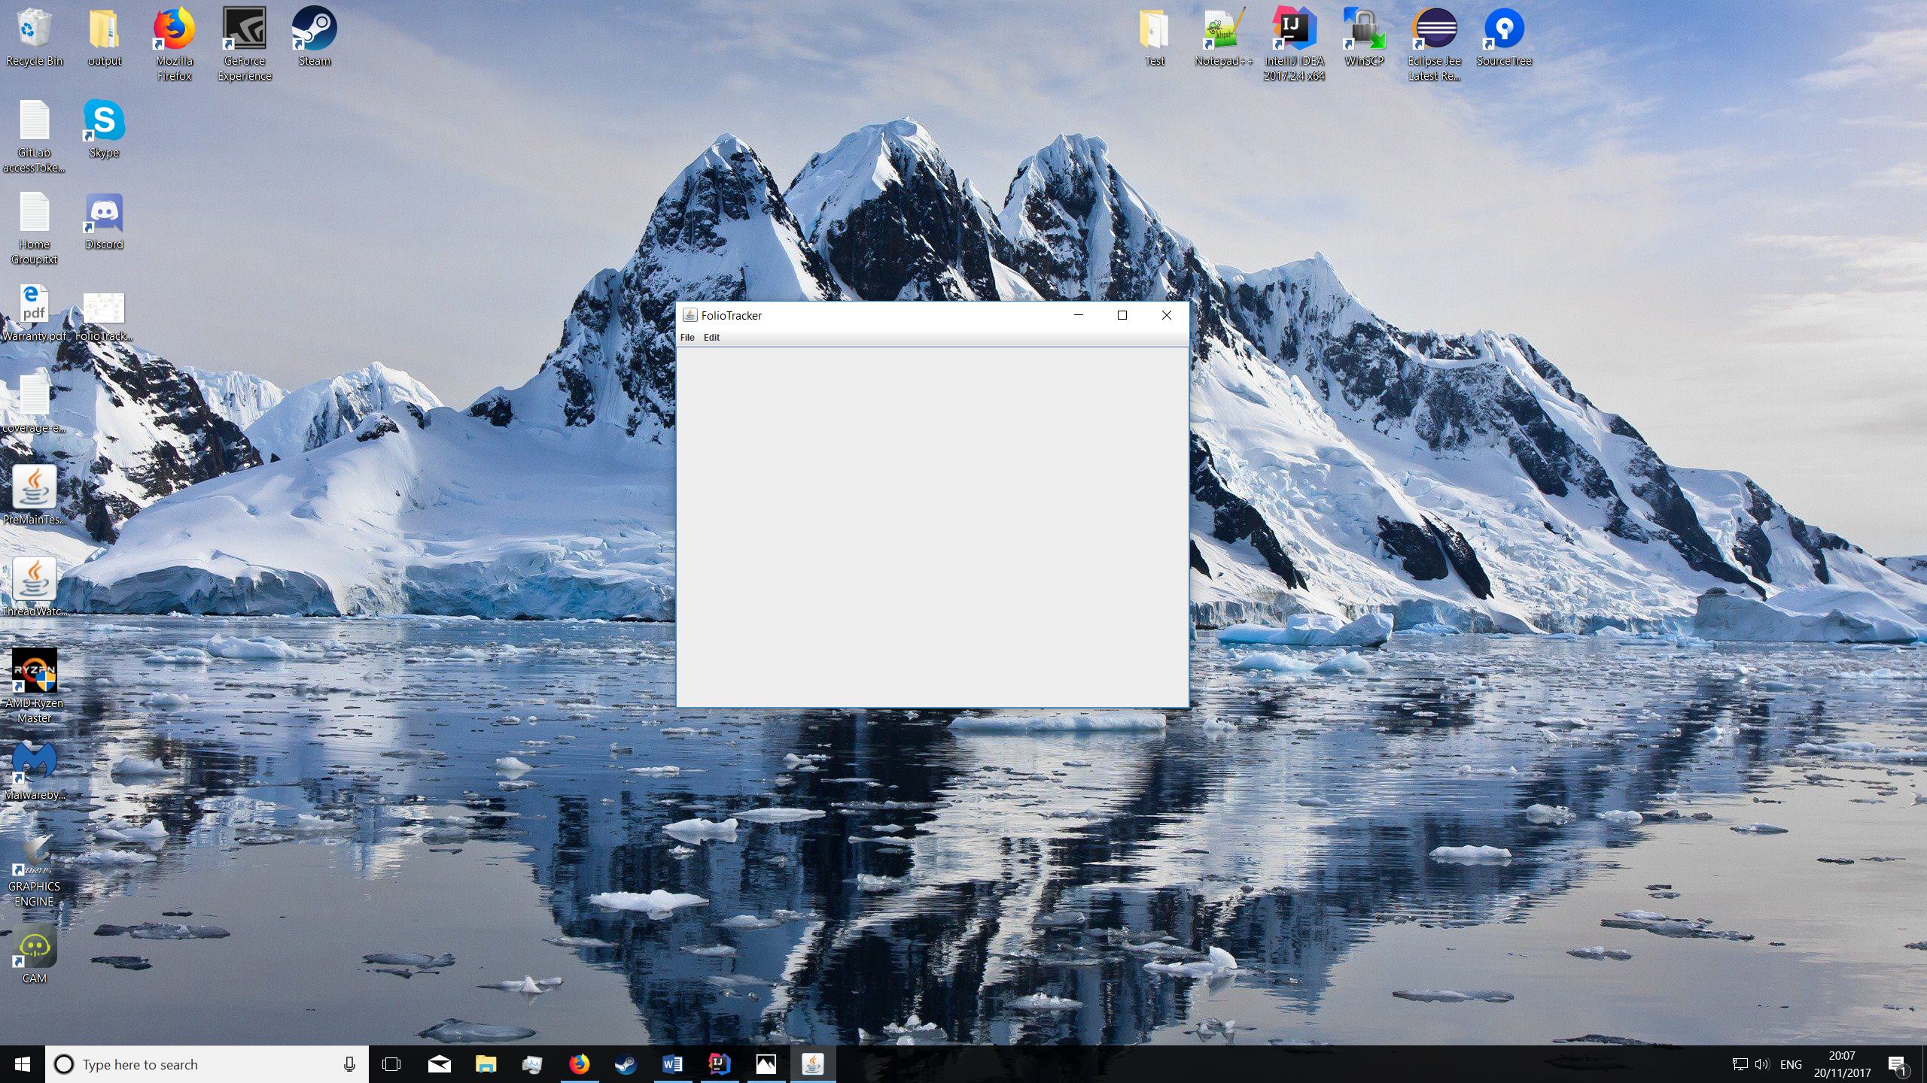Figure 5 – Delete confirmation

Figure 6 – Empty home screen after deletion

**Adding Stock**

Stocks are added by clicking on the ‘add stock’ button. A pop up will display after pressing which prompts for a ticker and the amount of stock you wish to buy. The ticker will then be verified and the price per share is received from the quote server and displayed.

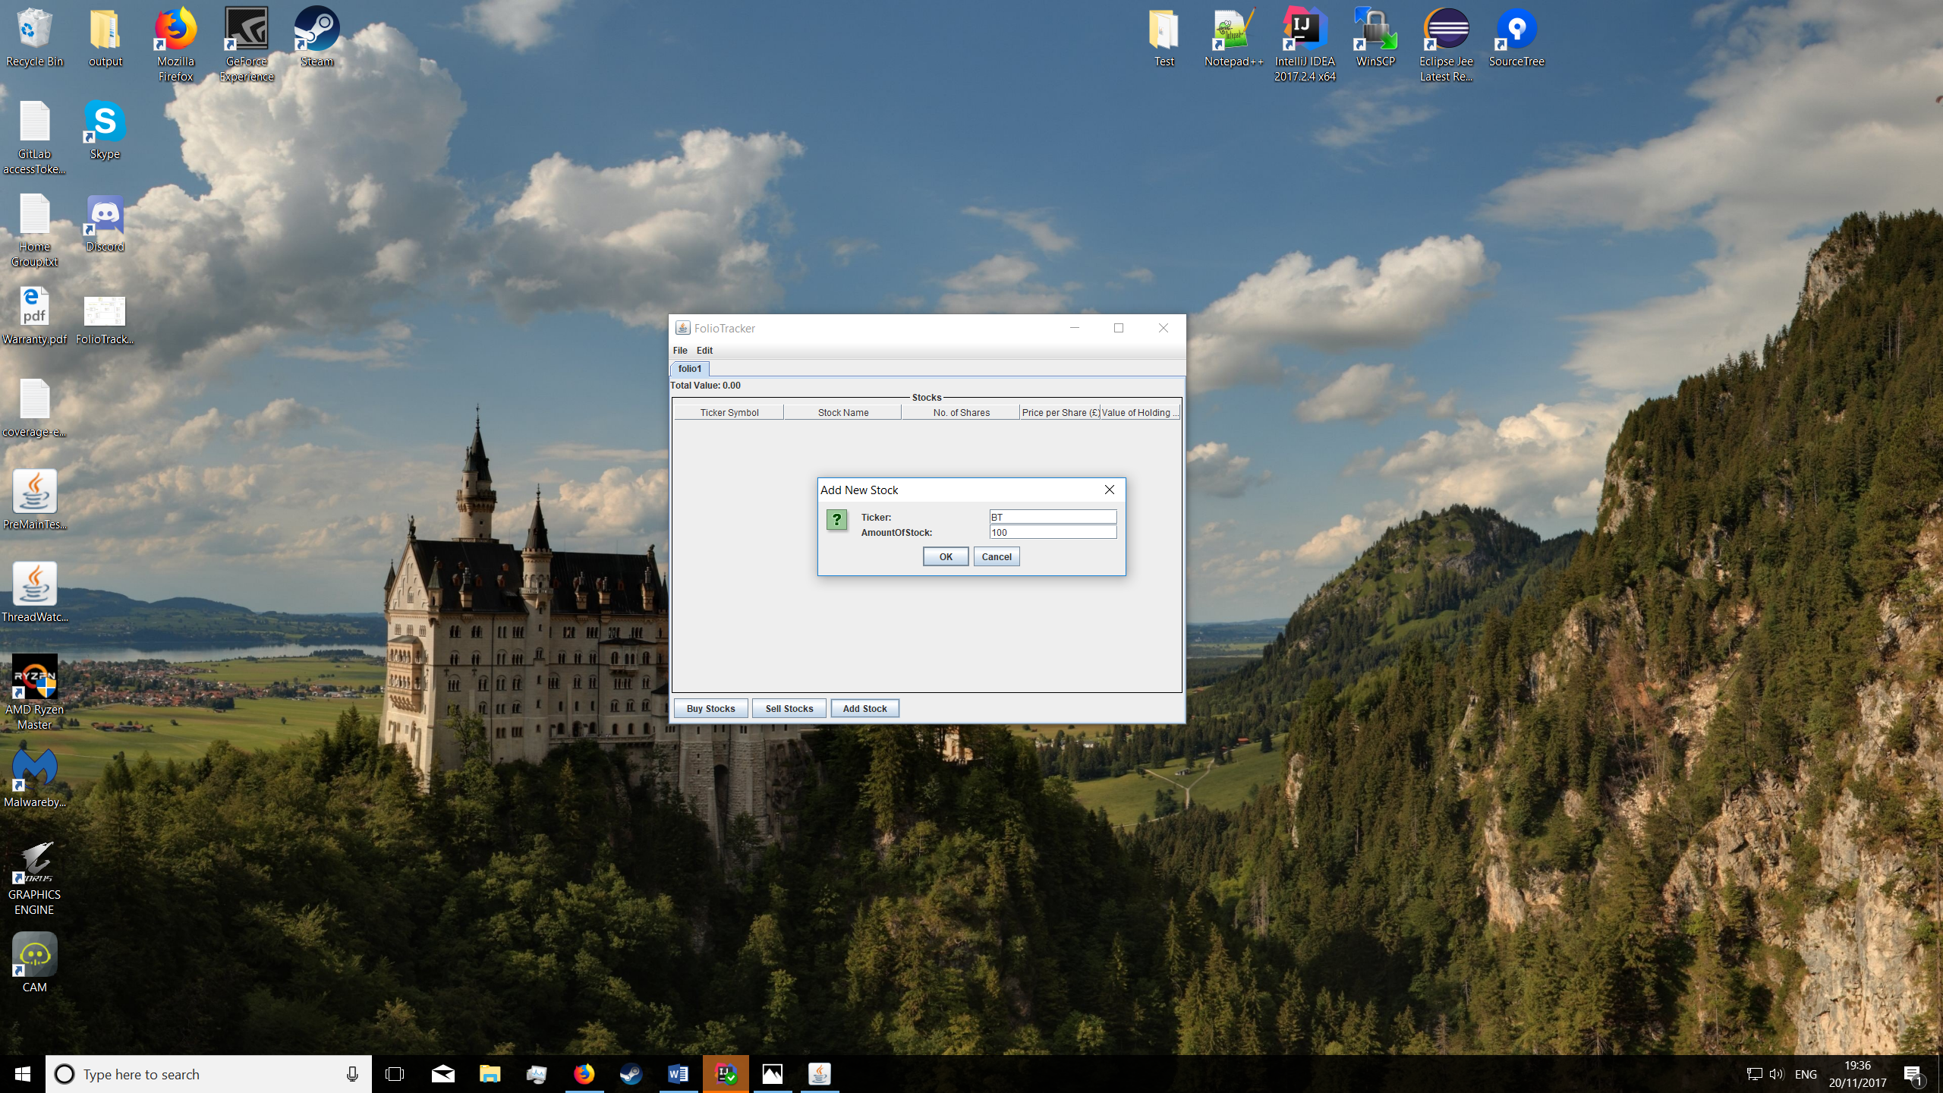

Figure 7 – Add stock button and ticker/amount of stock prompt

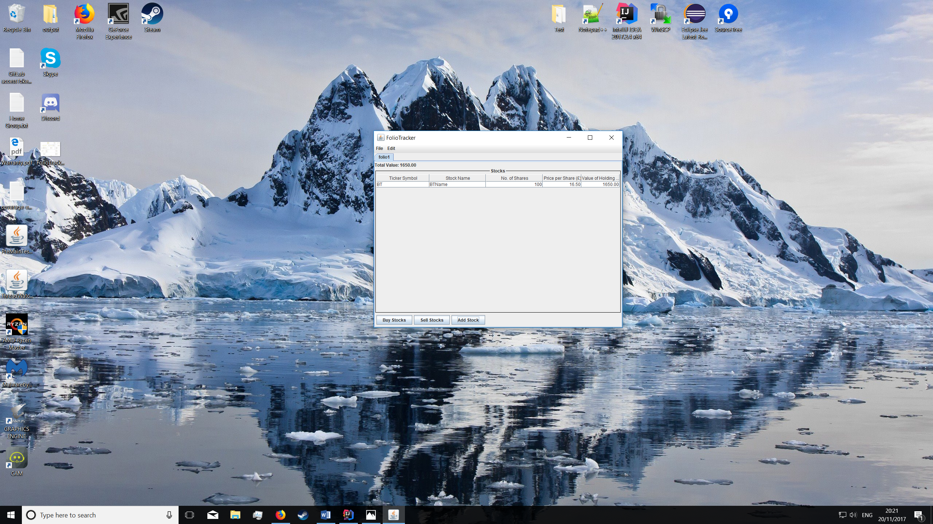

Figure 8 – stock information displayed

**Buying stock**

In order to buy stock, you must start by first selecting the row of stock which you wish to buy more of and then press the ‘buy stock’ button. You will then be prompted by a pop-up to enter the number of shares you want. The number of shares will then increase by the appropriate value; as shown is *figure 10.*

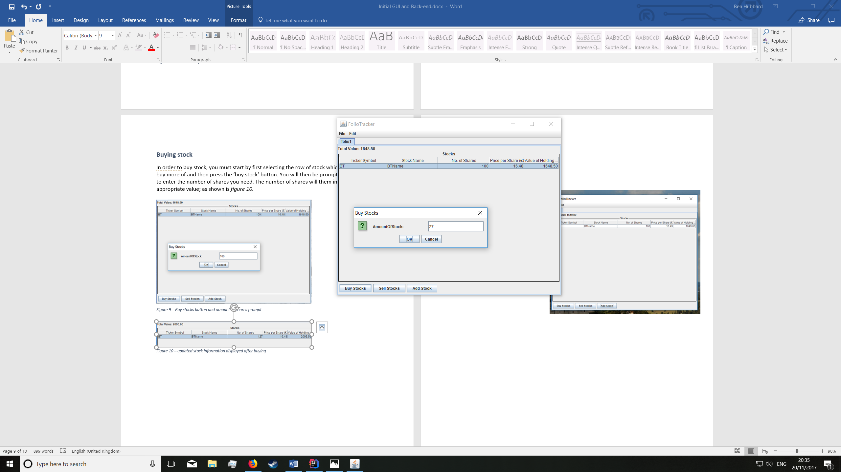

Figure 9 – Buy stocks button and amount of shares prompt

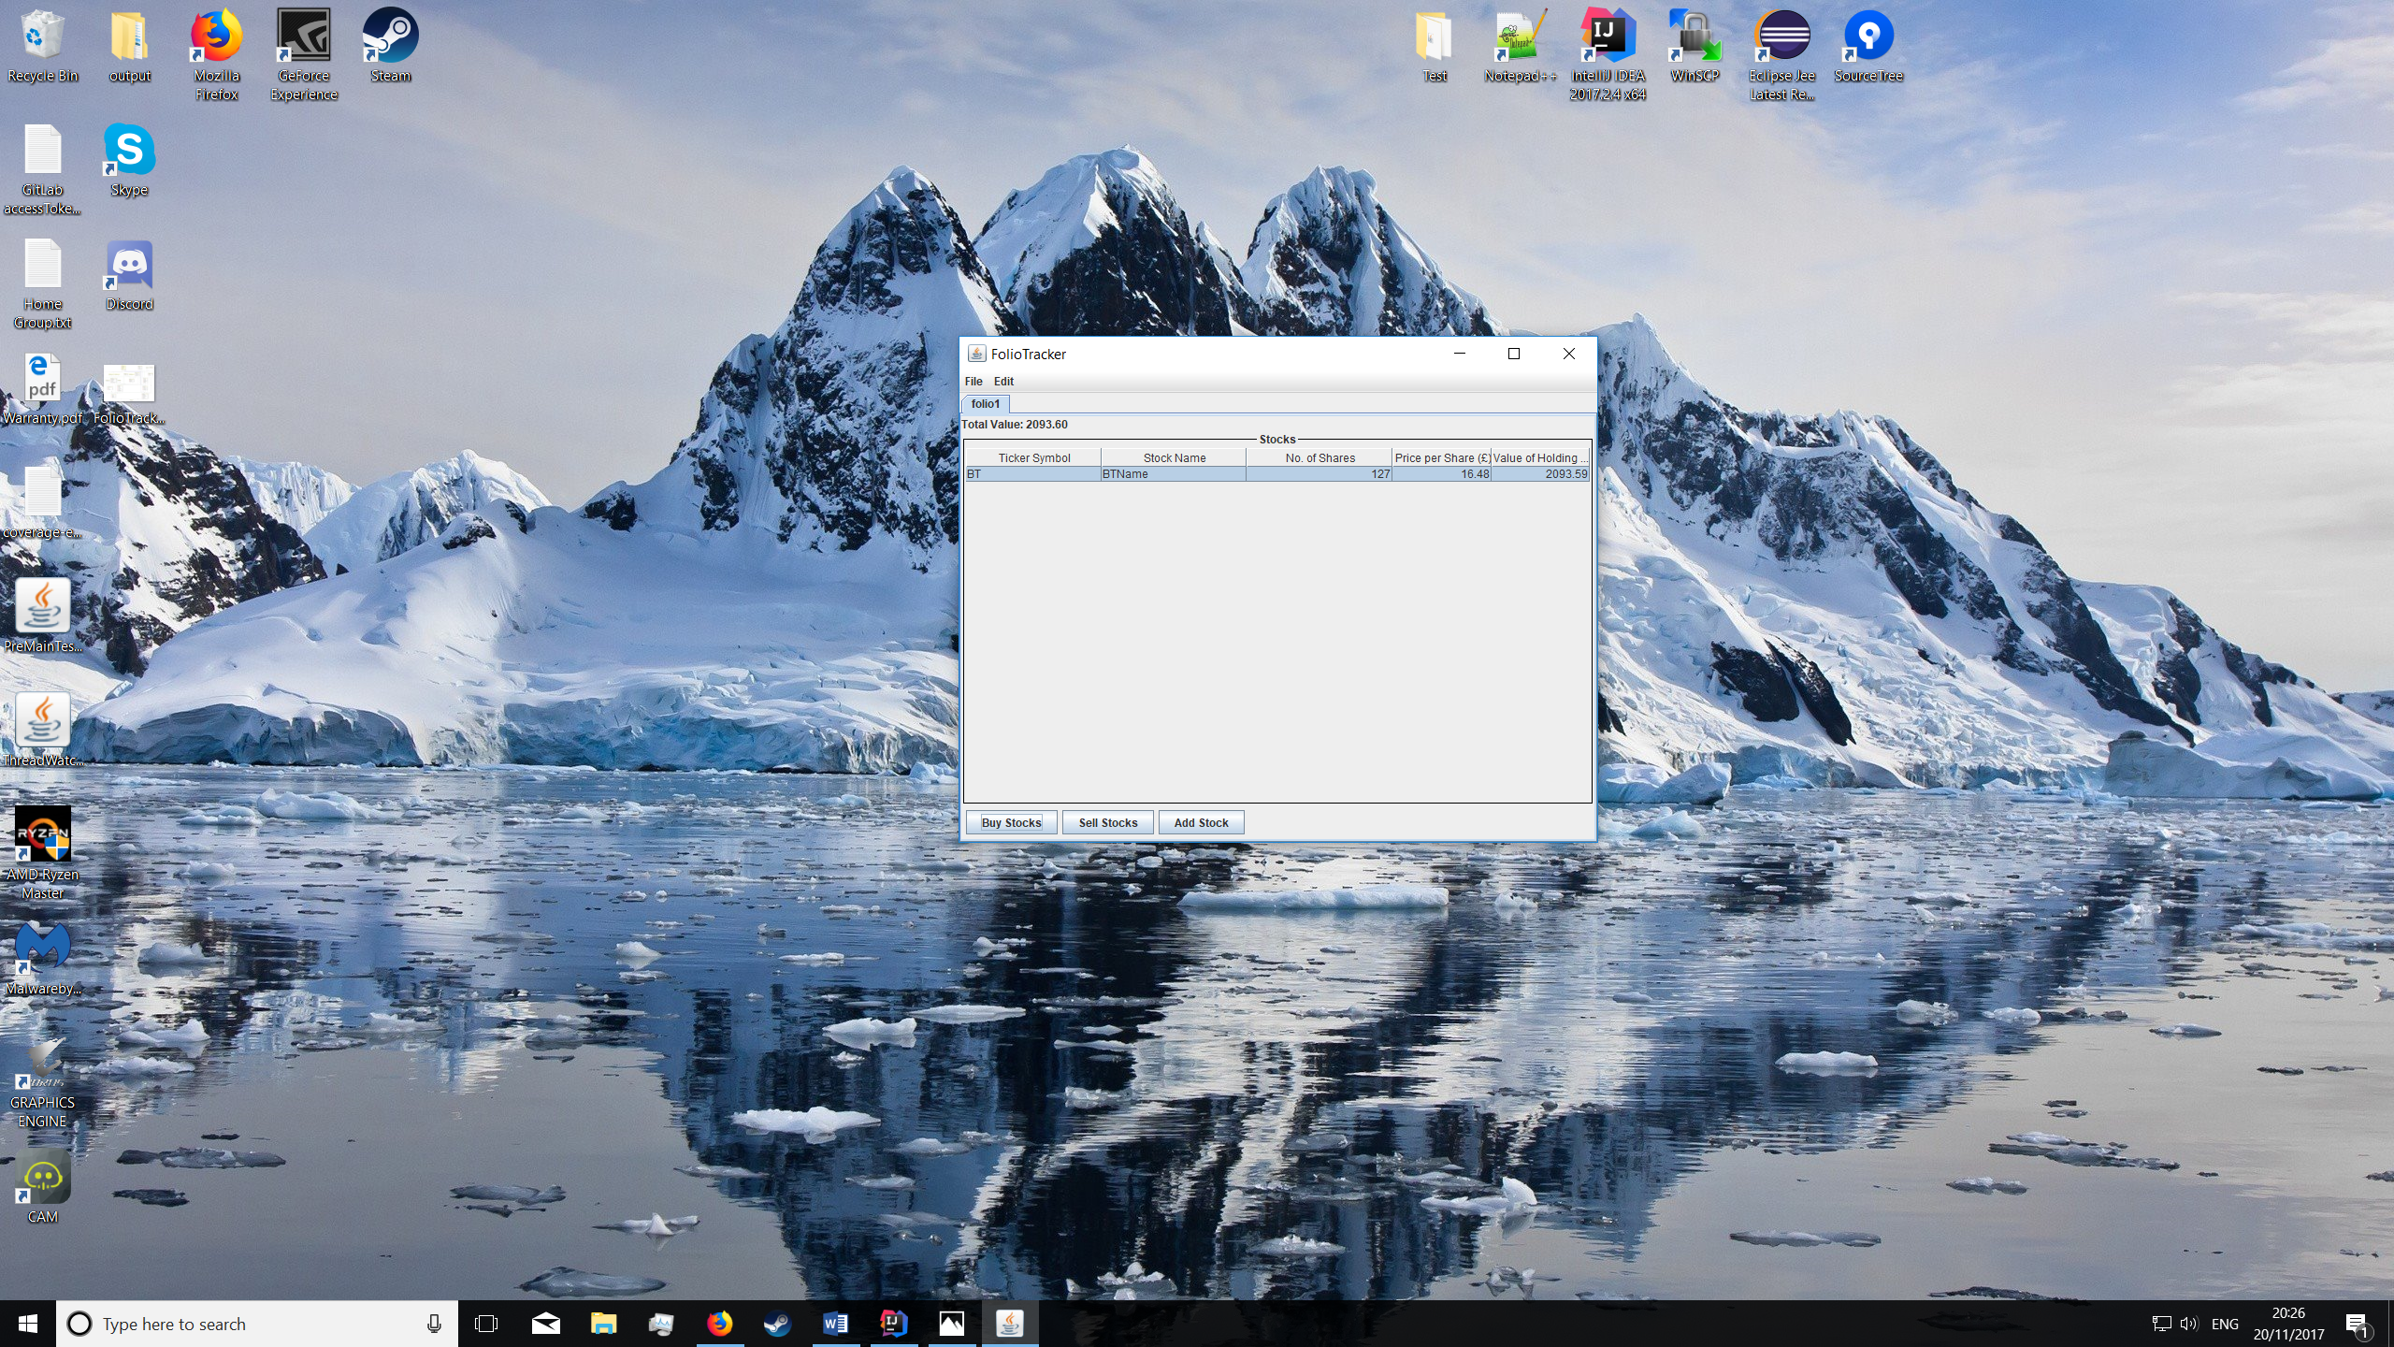

Figure 10 – updated stock information displayed after buying

**Selling stock**

In order to sell stock, you must start by first selecting the row of stock which you wish to sell and then press the ‘sell stock’ button. You will then be prompted by a pop-up to enter the number of shares you want to sell. The number of shares will then decrease by the appropriate value; as shown is *figure 10.* In order to remove a stock this process would be followed but all shares of the particular stock would be sold.

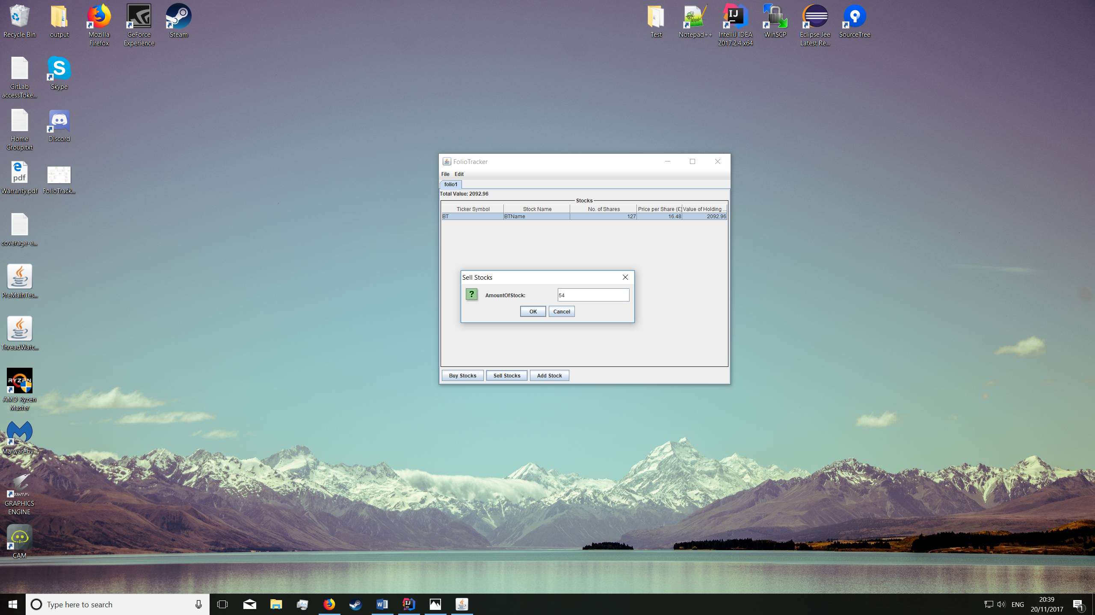

Figure 11 – Sell stocks button and amount of shares prompt

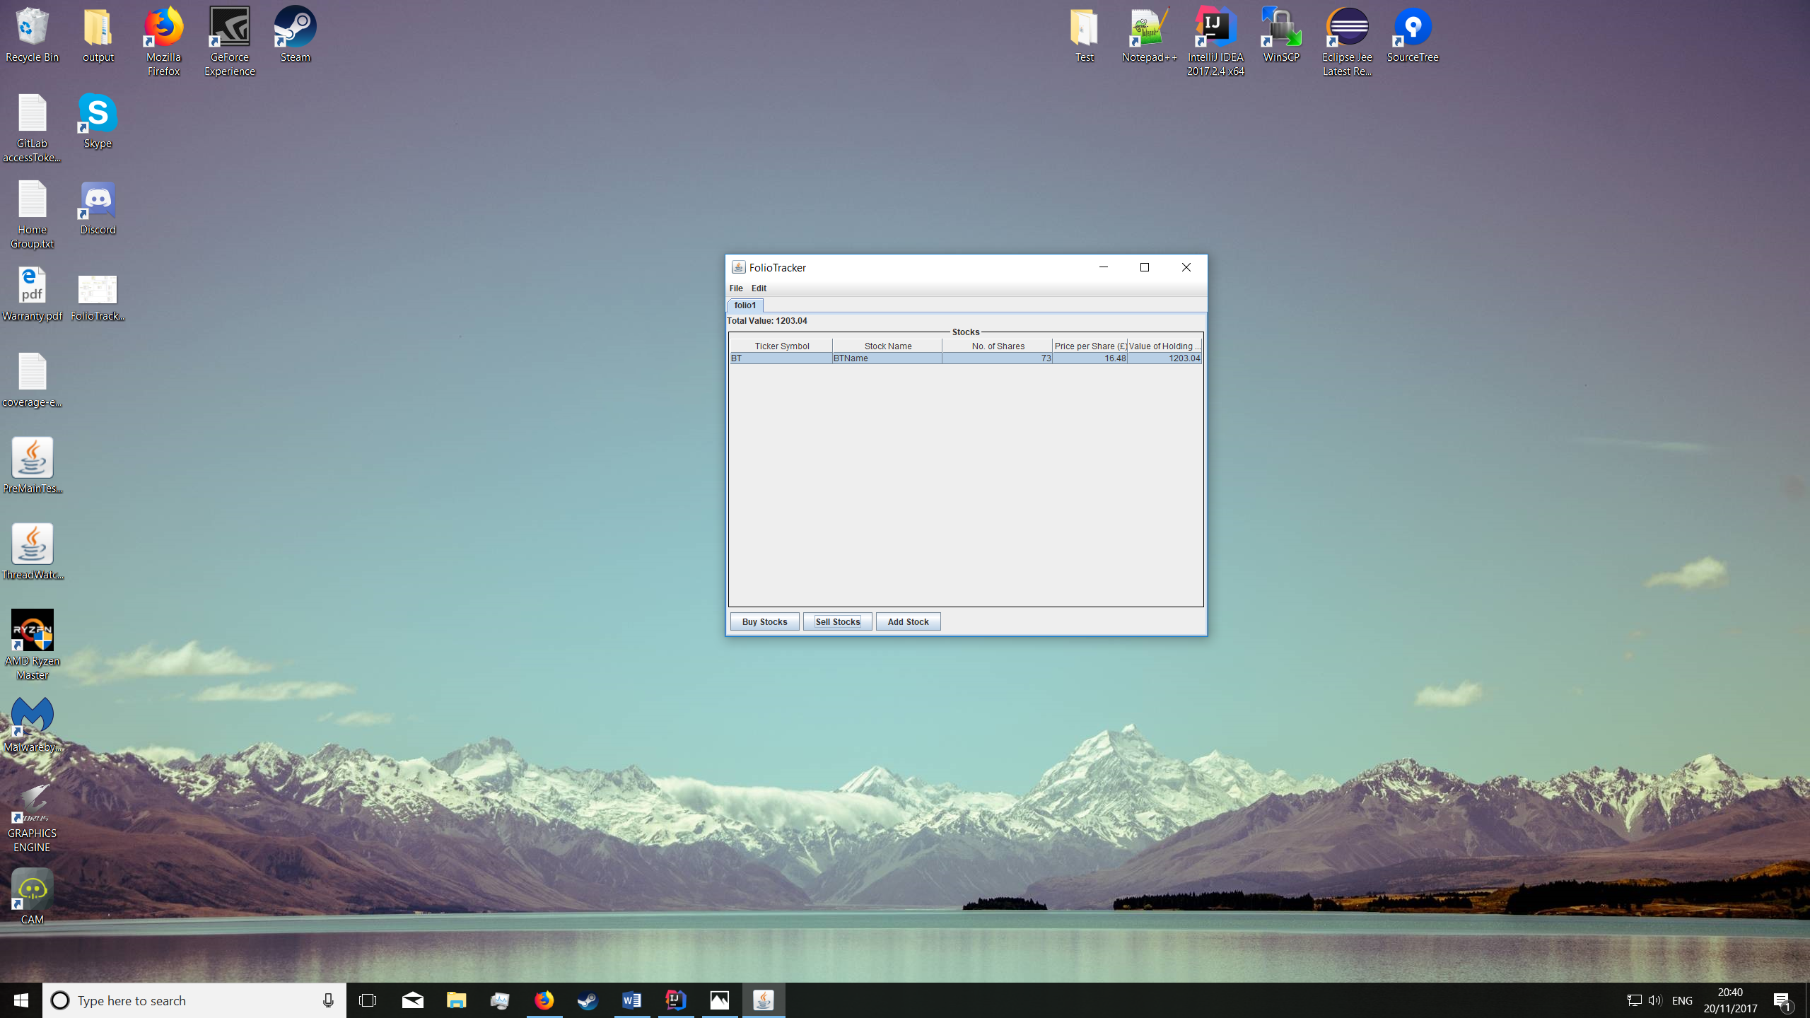

Figure 12 – updated stock information displayed after buying

**Display**

Managing portfolios and total value of portfolio can be seen in *figure 13.*

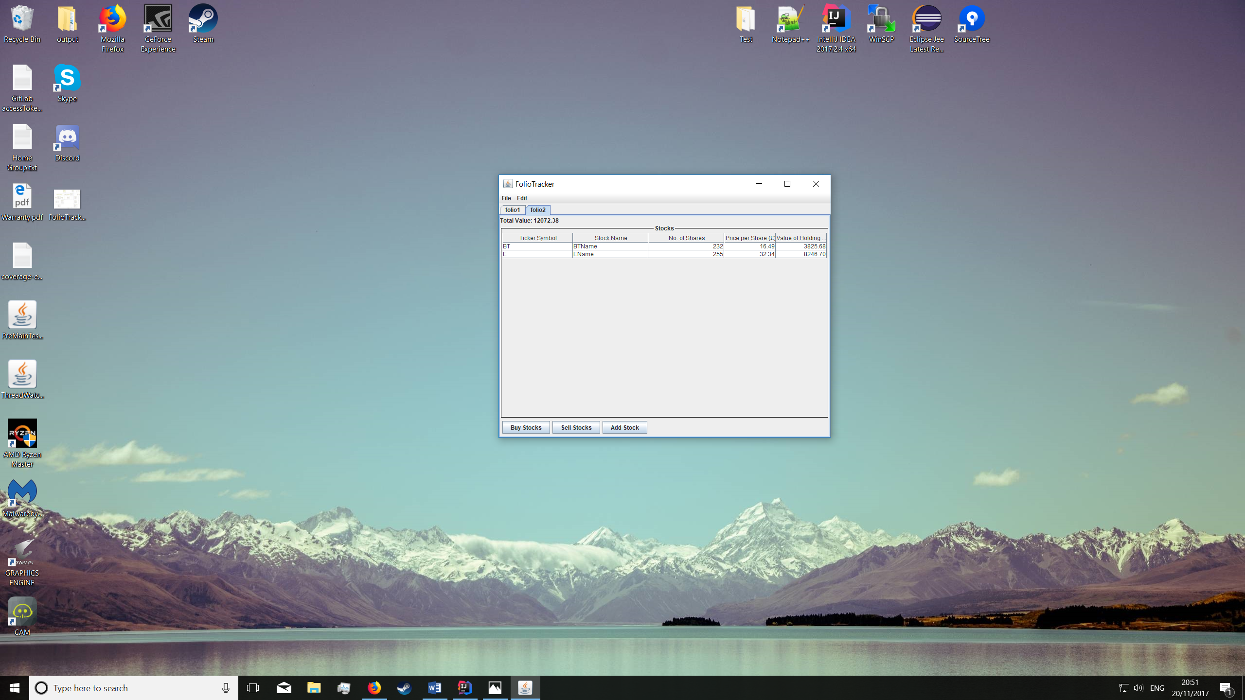

Figure 13 – multiple portfolios and total value